Section1: What I believe I can give to a team:
- A. I can quickly see and take advantage of new opportunities.
- B. I can work well with a very wide range of people.
- C. Coming up with ideas is one of my good points.
- D. I’m good at getting other people to talk about their ideas and points of view.
- E. My ability to finish things has much to do with my personal effectiveness.
- F. I am ready to face temporary unpopularity if it leads to worthwhile results in the end.
- G. I am quick to realise what is likely to work in a situation with which I am familiar.
- H. I can offer a reasoned case of alternative courses of action without introducing bias or prejudice.

SECTION 2.
One of my weaknesses in teamwork could be that:
- A. I am not at ease unless meetings are well structured and controlled and generally well conducted.
- B. I am inclined to be too generous towards others who have a valid viewpoint that has not been given a proper airing.
- C. I probably talk a lot once the group gets onto new ideas.
- D. My realistic outlook makes it difficult for me to join in enthusiastically with the rest of the team
- E. I am sometimes seen as forceful and bossy if there is a need to get something done.
- F. I find it difficult to lead from the front, perhaps I am over-responsive to group atmosphere.
- G I am apt to get too caught up in ideas that occur to me and so lose track of what is happening.
- H. My colleagues tend to see me as worrying unnecessarily over detail and the possibility that things may go wrong.

SECTION 3.
When involved in a project with other people:
- A. I am good at influencing people without pressurising them.
- B. My general carefulness prevents careless mistakes and omissions being made.
- C. I am ready to press for action to make sure that the meeting does not waste time or lose sight of the main objective.
- D. I can come up with something original.
- E. I am always ready to back a good suggestion in the common interest.
- F. I am keen to look for the latest in new ideas and developments.
- G. I believe my capacity for cool judgements is appreciated by others.
- H. I can be relied upon to see that all essential work is organised.

SECTION 4.
My characteristic approach to group work is that:
- A I have a quiet interest in getting to know colleagues better.
- B I am happy to challenge the view of others or to hold a minority view myself.
- C I can usually find a line of argument to refute unsound suggestions.
- D I think I have a talent for making things work once a plan has to be put into operation.
- E I have a tendency to avoid the obvious and to come out with the unexpected.
- F I bring a touch of perfectionism to any team job I undertake.
- G I am ready to make use of contacts outside the group itself.
- H While I am interested in all views, I have no hesitation in making up my mind once a decision has to be made.

SECTION 5.
I gain satisfaction in a job because:
- A. I enjoy examining situations and weighing up all the possible choices.
- B. I am interested in finding practical solutions to problems.
- C. I like to feel I am developing good working relationships
- D. I can have a strong influence on decisions
- E. I can meet people who may have something new to offer.
- F. I can get people to agree on a necessary course of action.
- G. I feel in my element where I can give a task my full attention.
- H. I like to find a field that stretches my imagination.

SECTION 6.
If I am suddenly given a difficult task with limited time and unfamiliar people:
- A. I would feel like retiring to a corner to think of a way out of the problem before saying anything.
- B. I would be ready to work with the person who showed the most positive approach, however difficult they may be.
-C. I would find some way of reducing the size of the task by establishing what different individuals might best contribute.
- D. My natural sense of urgency would help to ensure that we did not fall behind schedule.
-E. I believe I would keep cool and maintain my capacity to think straight.
-F. I would retain a steadiness of purpose in spite of the pressures.
-G. I would be prepared to take a positive lead if I felt the group was not making progress.
-H. I would open up discussions with a view to stimulating new thoughts and getting something moving.

SECTION 7.
I am sometimes negative when I work in groups by:
- A. Showing my impatience with those who are getting in the way of progress.
- B. Being too analytical and not using my “gut” feelings.
- C. My desire to see that work is properly done can hold up progress.
-D. Getting bored rather easily, and relying on one or two stimulating members to spark me off.
-E. I find it difficult to get started unless the goals are clear.
-F. I am sometimes poor at explaining and clarifying complex points that occur to me.
-G. I am conscious of demanding from others the things I cannot do myself.
-H. I hesitate to get my points across when I run up against real opposition.

Points table
In this table, work section by section, putting the points you allocated to the various sentences, next to the corresponding letters. In some sections the same letter appears more than once. Put the points you allocated next to all of the same corresponding letters i.e. section 4 has A twice so if you choose A then the score given will go against both letter A.
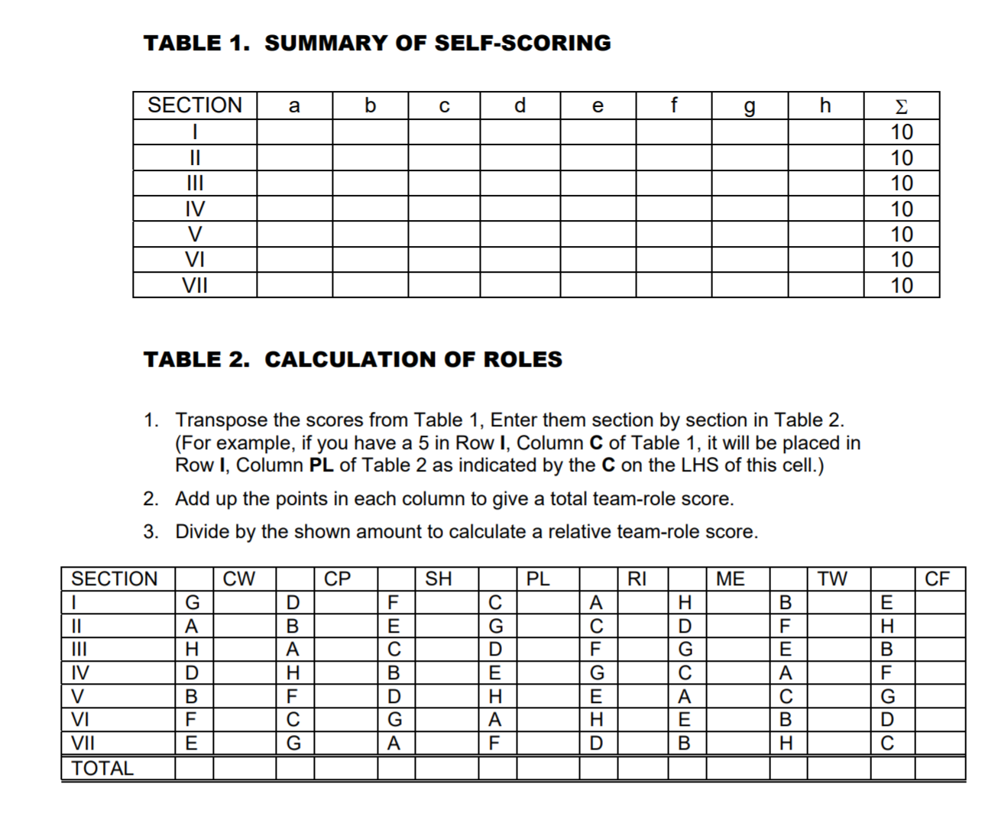
Add up the totals in the end column, reading across the rows.
First Header | Second Header
Content Cell | Content Cell
Content Cell | Content Cell

